- SIGNAL GENERATION AND BASIC SIGNAL OPERATIONS

Experiment 3.1
Addition and Multiplication of Two Sequences
Program:
clc;
clear;
close all;
% Sample index
n = 0:10;
% Sequence 1
x1 = [1 2 3 4 5 6 7 8 9 10 11];
% Sequence 2
x2 = [11 10 9 8 7 6 5 4 3 2 1];
% Addition of sequences
y_add = x1 + x2;
% Multiplication of sequences
y_mul = x1 .* x2;
% Plotting
figure;
subplot(2,2,1);
stem(n,x1,'filled');
grid on;
title('Sequence x_1(n)');
xlabel('n');
ylabel('Amplitude');
subplot(2,2,2);
stem(n,x2,'filled');
grid on;
title('Sequence x_2(n)');
xlabel('n');
ylabel('Amplitude');
subplot(2,2,3);
stem(n,y_add,'filled');
grid on;
title('Addition: x_1(n) + x_2(n)');
xlabel('n');
ylabel('Amplitude');
subplot(2,2,4);
stem(n,y_mul,'filled');
grid on;
title('Multiplication: x_1(n) * x_2(n)');
xlabel('n');

ylabel('Amplitude');
Output Waveform: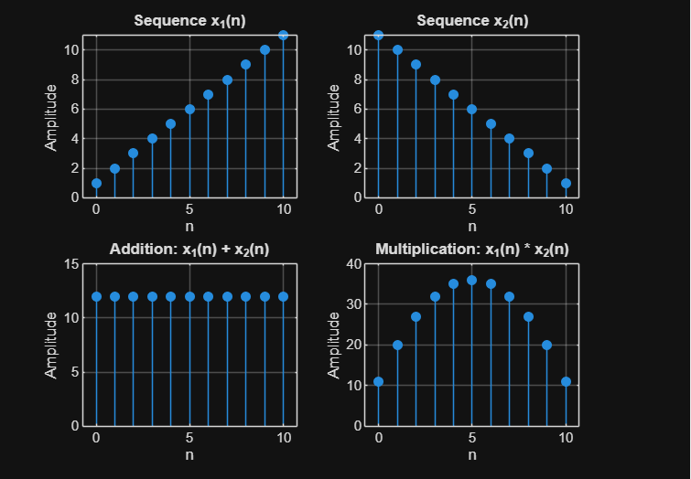
Result:
Two discrete-time sequences were generated and their addition and point-wise multiplication
were performed successfully using MATLAB. The resulting sequences were displayed using
stem plots, illustrating basic operations on discrete-time signals.

Experiment 3.2
% Autocorrelation of a Signal
clc;
clear;
close all;
% Input Signal
x = [1 2 3 4 5];
% Autocorrelation
Rxx = xcorr(x);
% Lag values
lags = -(length(x)-1) :(length(x)-1);
% Display result
disp('Autocorrelation Sequence:');
disp(Rxx);
% Plot
figure;
stem(lags,Rxx,'filled');
grid on;
title('Autocorrelation of Signal');
xlabel('Lag');
ylabel('R_{xx}(k)');

Expected Output: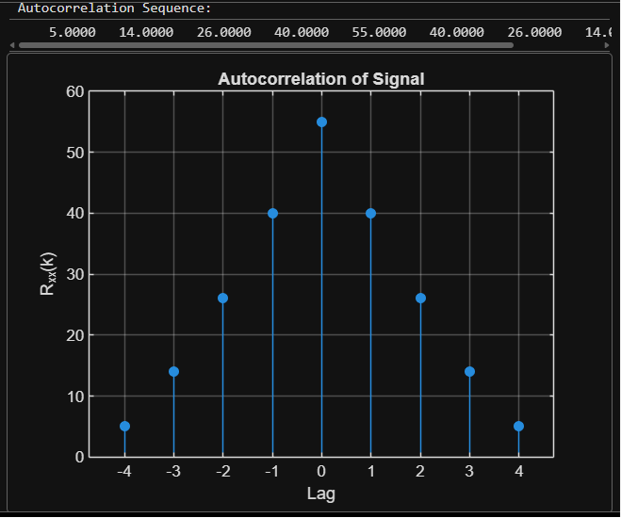

Result:

The autocorrelation of the given discrete-time signal was computed using MATLAB. The
autocorrelation sequence was symmetric about zero lag, and the maximum value occurred at
zero lag, indicating the highest similarity of the signal with itself.

